Student: Ulvi Bajarani
Student ID: 20539914
Instructor: Dr. Bin Fu.
Due Mar. 11, 2021 (Thursday).

Answer 1.

a) the algorithm for string S with the length n if the string S might be reconstructed:

set D[0] = True;
for k from 1 to n-1 (inclusive):
set D[k] = False;
for j from 1 to k (inclusive):
if (D[j-1] == True) and (dict(substring of S from j to k)) == True:
set D[k] = True;
return D[n-1]

b) the algorithm for string S with the length n to execute sequence of words in D:

print(S[0] + ‘ ’);
for x from 1 to n-1 (inclusive):
for y from x to 1 (inclusive):
if D[x] == True and D[y] == True and dict(substring of S from x to y) == True:
print([substring of S from x to y] + ‘ ’)

Answer 2.

a) Binomial tree B₀ has 1 node, and binomial tree B₁ has B₀ + B₀ = 2 nodes. So, binomial trees with B_{k} has B_{n-1} + B_{n-1} = 2^{n} nodes, according to definition. Let’s proof that B_{k+1} has 2^{k+1} nodes. In this case, B_{k+1} = B_{k} + B_{k} = 2^{k} + 2^{k} = 2 * 2^{k} = 2^{k+1} . So, the binomial tree B_{n} has 2^{n} nodes.

Now, let’s calculate the number of trees in the heap H with n nodes. We can write that for k trees, the maximum of n = 2⁰+2¹ + … + 2^{k-1} for k ≥ 0. In this case, the maximum order of tree in the heap is equal to k-1=floor(log₂n). In other words, if the maximum order is k-1, there is no tree with the order higher or equal to k-1. Since the maximum number of trees occurs when the difference of orders between all trees equal to 1, the possible maximum number of trees is k = 1 + floor(log₂n).

b) Since the number of roots equal to number of trees, the maximum number of roots in the H₁ = 1 + floor(log₂n₁) and H₂ = 1 + floor(log₂n₂) . So, total number of roots in H with n roots is at most H₁ + H₂ = 1 + floor(log₂n₁) + 1 + floor(log₂n₂) = 2 + floor(log₂n₁) + floor(log₂n₂). Since merging each heap (H₁ and H₂) to the new heap H takes O(1) time, the total number of iterations for heap rearranging takes at most 2 + floor(log₂n₁) + floor(log₂n₂) = O(logn) time.

c) The H₁ , H₂, and their union result:
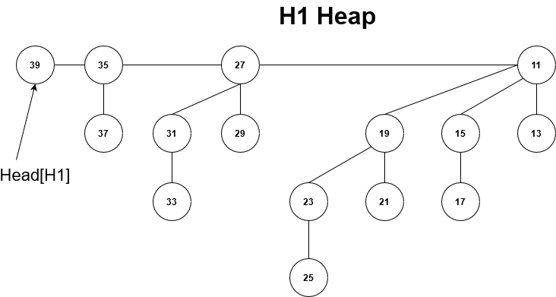

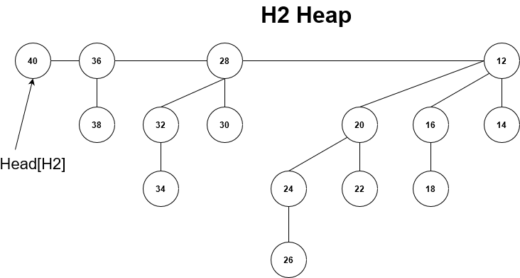

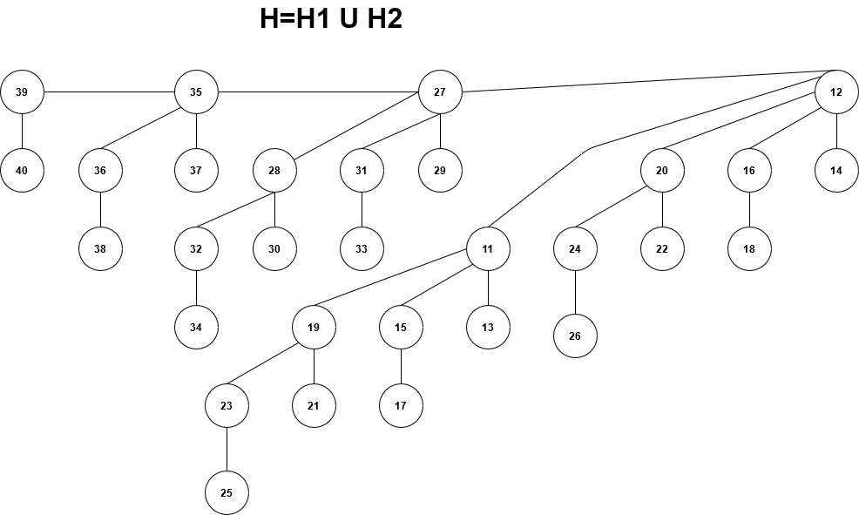

Answer 3.

a) The algorithm for the array A with size n and target number T:

create array AvailableSubset[n][T+1] with all values equal to False;
set AvailableSubset[0][x] = True for all x;
set AvailableSubset[j][0] = True for all j;
for i from 1 to n-1 (inclusive):
for j from 0 to T (inclusive):
if A[i] > j:
set AvailableSubset[i][j] = AvailableSubset[i-1][j], A[i] or AvailableSubset[i-1][T-A[i]]
else:
set AvailableSubset[i][j] = AvailableSubset[i-1][j];
set x=T
while (AvailableSubset[n][T] == False)
do:
x-=1;
for i from n-1 to 1 (inclusive):
if (AvailableSubset[i][check_value] != AvailableSubset[i-1][check_value]) and (AvailableSubset[i][j] != false):
print(A[i] + ‘ ’);
set check_value = T-A[i]
if check_value ≤ 0:
break;

return AvailableSubset[n][T];

To prove if our algorithm is right, we have to know two cases:

1) The number A[i] is not added to the subset. In this case, the size n for array A reduces to n-1, and the distance to the target number T remains same.

2) The number A[i] is not added to the subset. In this case, the size n for array A reduces to n-1, and the distance to the target number reduces to T-A[j]. This is done only if A[j] < T.

The computational time for array with size n is O(n*T), since there are nested loops. Printing and saving results requires O(n) time, since we have to check only array indices.

b) The code of the program:

#include <iostream>
#include <fstream>
#include <chrono>
#include <vector>
#include <algorithm>
#include <string>

bool** check_vector;
std::ofstream myfile;

std::string str = "";

void printing_available_subsets(int a[], int i, int s, std::vector<int>& p)
{

if (i == 0 && s != 0 && check_vector[0][s])
{
p.push_back(a[i]);
if (a[i] == s)
{
for (int i = 0; i < p.size(); ++i)
{
printf("%d ", p[i]);
str += std::to_string(p[i]);
str += " ";
}
printf("\n");
str += "\n";
}
return;
}

// If s becomes 0
if (i == 0 && s == 0)
{
for (int i = 0; i < p.size(); ++i)
{
printf("%d ", p[i]);
str += std::to_string(p[i]);
str += " ";
}
printf("\n");
str += "\n";
return;
}

if (check_vector[i - 1][s])
{
std::vector<int> b = p;
printing_available_subsets(a, i - 1, s, b);
}

if (s >= a[i] && check_vector[i - 1][s - a[i]])
{
p.push_back(a[i]);
printing_available_subsets(a, i - 1, s - a[i], p);
}
}

int knapsack(int a[], int n, int s, std::vector<int>& subset)
{
if (n == 0 || s < 0)
return 0;
check_vector=new bool* [n];
for (int i = 0; i < n; ++i)
{
check_vector[i] = new bool[s + 1];
check_vector[i][0] = true;
}

if (a[0] <= s)
check_vector[0][a[0]] = true;
for (int i = 1; i < n; i++)
{
for (int j = 0; j < s+1; j++)
{
if (a[i] > j)
{
check_vector[i][j] = check_vector[i - 1][j] || check_vector[i - 1][j - a[i]];
}
else
{
check_vector[i][j] = check_vector[i - 1][j];
}
}
}

printing_available_subsets(a, n - 1, s, subset);
return 0;
}

int main()
{
int a[] = { 5, 23, 27, 37, 48, 51, 63, 67, 71, 75, 79, 83, 89, 91, 101, 112, 121, 132, 137, 141, 143,
147, 153, 159, 171, 181, 190, 191};
std::vector<int> subset = {};
int n = 16;
int knapsack_value = 762;
knapsack(a, n, knapsack_value, subset);
myfile.open("results.txt", std::ios::app);
myfile << str << std::endl;

return 0;
}

All outputs equal to 762 when size=16 (34 answers):

101 91 89 79 75 71 67 63 51 48 27
101 91 89 83 75 71 67 63 51 48 23
101 91 89 83 79 75 71 67 51 27 23 5
112 89 83 79 75 71 67 51 48 37 27 23
112 91 89 79 75 67 63 51 48 37 27 23
112 91 89 79 75 71 67 63 51 37 27
112 91 89 83 71 67 63 51 48 37 27 23
112 91 89 83 75 71 67 63 51 37 23
112 91 89 83 79 75 67 63 48 27 23 5
112 91 89 83 79 75 71 63 51 48
112 91 89 83 79 75 71 67 63 27 5
112 101 83 79 71 67 63 51 48 37 27 23
112 101 83 79 75 71 67 63 51 37 23
112 101 89 79 75 71 67 51 48 37 27 5
112 101 89 83 75 71 63 51 48 37 27 5
112 101 89 83 75 71 67 63 51 27 23
112 101 89 83 79 67 63 51 48 37 27 5
112 101 89 83 79 75 67 63 51 37 5
112 101 89 83 79 75 71 67 48 37
112 101 91 79 75 71 67 63 48 27 23 5
112 101 91 83 75 71 67 63 51 48
112 101 91 83 79 75 67 51 48 27 23 5
112 101 91 83 79 75 71 63 37 27 23
112 101 91 83 79 75 71 67 51 27 5
112 101 91 89 71 67 63 51 48 37 27 5
112 101 91 89 75 71 67 63 51 37 5
112 101 91 89 79 75 67 63 48 37
112 101 91 89 83 71 67 63 48 37
112 101 91 89 83 75 71 48 37 27 23 5
112 101 91 89 83 79 67 48 37 27 23 5
112 101 91 89 83 79 71 51 48 37
112 101 91 89 83 79 71 67 37 27 5
112 101 91 89 83 79 75 63 37 27 5
112 101 91 89 83 79 75 67 37 23 5

